Novosibirsk International Triennial 2018
The Second International Triennial
of Contemporary Graphic Arts in Novosibirsk
features works of 10 international Artists -
selected and curated by Derek Michael Besant RCA
Artists: Wuon-Gean Ho, Edward James Bateman, Vladimir Martynov, Vicky Tsalamata, Alicja Habisiak Matczak, Edward Charles Bernstein, Alastair Clark, Rebecca Beardmore, Klavs Weiss, Michael Wegerer
Opening: 13.9.2018
Exhibition duration: 14.9. - 4. 11.2018
Novosibirsk State Art Museum
Красный пр-кт, 5, Novosibirsk, Novosibirskaya oblast',
630007 Russland
link> https://www.nsartmuseum.ru/
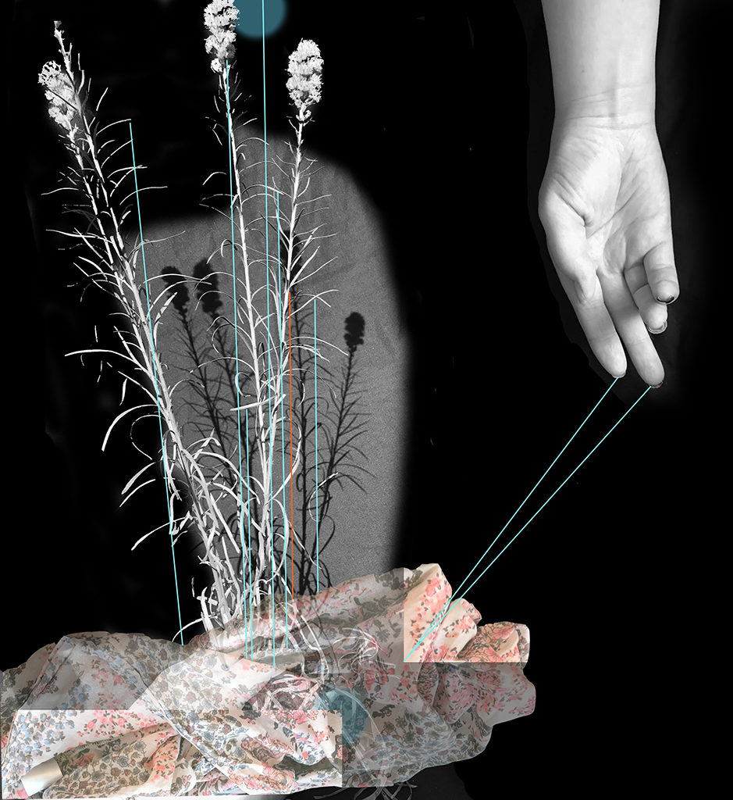
Touch Becoming Strange II (digital print, 24″ x 22″)
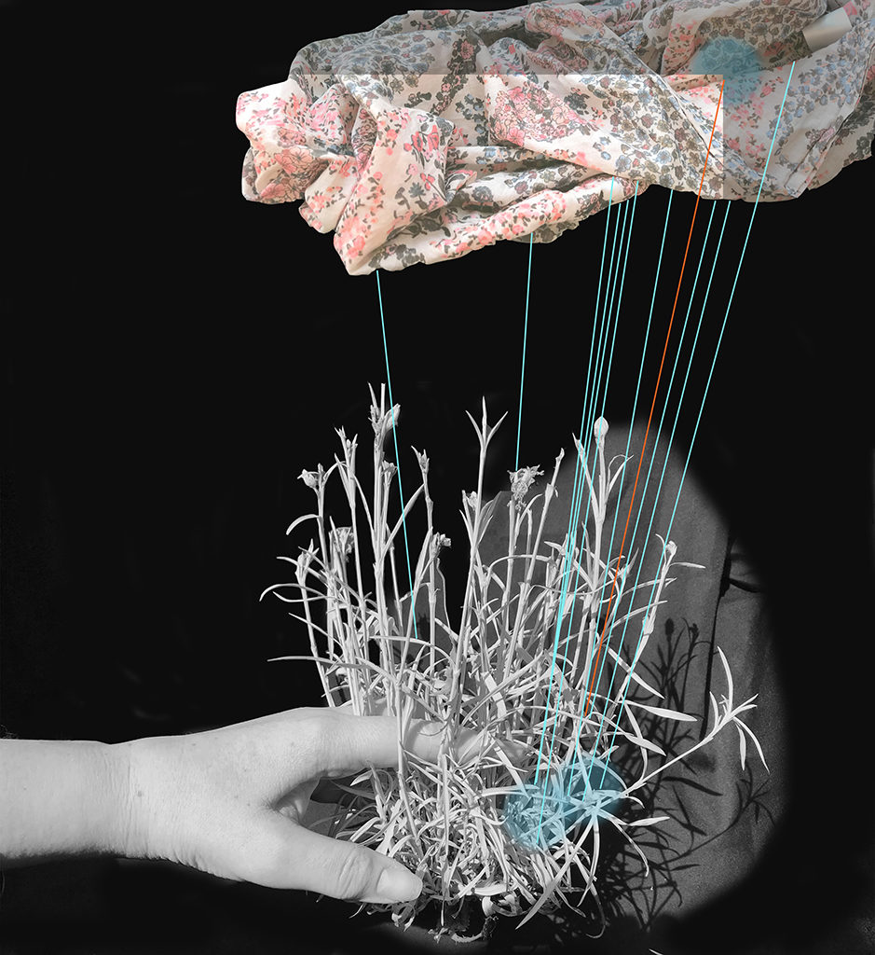
Touch Becoming Strange (digital print, 24″ x 22″)

About
Wuon-Gean Ho works in print, artist’s books and film, and has exhibited widely in juried, invited and solo shows for the past 25 years. She trained in water-based woodblock printmaking in Japan in 2000, and gained a distinction for her masters in Printmaking from the Royal College of Art in 2016.
She was studio technician for East London Printmakers' studio for four years, Chair of the organisation in 2016 and s currently a director of East London Printmakers C.I. C.. As a designer, she works on various projects including The UK Royal Mint Chinese Lunar calendar series of coins. As a writer, she is the news editor and regular author for the magazine Printmaking Today.
In 2009 and 2011 she coordinated the 2nd and 3rd International Printmaking Festival in Qijiang, Chongqing, China, including inviting artists and organising a symposium, and has been back to China as a visiting Famous Foreign Professor to Changsha Normal University in 2015 and 2017. From 2016–18 she was a print fellow at the RA schools in Piccadilly, London.
Selected Residencies
2018 Opificio della Rosa, Montefiore Conca, Italy, artist residency
2017 Atelier Presse Papier, Canada, residency and solo show
2017 Crow’s Shadow Institute of the Arts, USA, collaborative publishing project
2013 Portland Chinese Classical Garden, USA, artist residency
2011 Opificio della Rosa, Montefiore Conca, Italy, artist residency
2010 Bluecoat Arts Centre, Liverpool, artist residency
2009 and 10 Aberystwyth School of Art, Wales, visiting artist
2007 Sitka Center for Arts and Ecology, USA, artist residency
2005 Kyoto Seika University Research studentship
2004 Intaglio Printmaker artist residency
2001-3 Printspace artist residency
Selected Awards
2017 Award Presse Papier, Biennale Internationale d’Estampe Contemporaine de Trois-Rivières, Quebec, Canada
2014 First Prize for Books of Desire, Classense Library, Ravenna, Italy
2014 British Institution Award at the Royal Academy Summer show
2010 Birgit Skiold Memorial Trust prize for Embrace, an artists’ book
2009 Printmakers Council Prize for Sleeper series
2007 John Purcell Paper Prize for China Love series
1998-2000: Osaka University of Education and Kyoto Seika University, Japan. Scholarship student sponsored by the Japanese Government
Selected Shows
2018 Rene Carcan International Printmaking Prize, Brussels, Belgium, shortlisted
Baksi: Sahasi/ Print: Pressure. Arte Sanat, Ankara, Turkey
Bainbridge Print Open, ASC Gallery, London
National Original Print Exhibition, London
Japan, West Yorkshire Print Workshop
Tokyo International Mini Print Triennial, Japan
​ Second International Triennial of Contemporary Graphic Arts 2018 Novosibirsk, Russia, invitational
2017 Splitgraphik, 8th International Graphic Art Biennial, Croatia
Masters Monoprint, Bankside Gallery London (animation)
Seventh Sense, Atelier Press Papier, Trois Rivieres, Canada (solo show)
BIECTR, Trois Rivieres, Canada
Selected work from BIECTR at Galerie A. Piroir, Montreal, Canada
Printing and Animation, New York Center for Book Arts, Manhattan, New York, USA (animation)
Royal Academy Summer Show London
Highlights of the RA summer show, selected by Norman Ackroyd, Zillah Bell Gallery, Thirsk
London Original Print Fair, as part of Art China Gallery
Paul Croft and Wuon-Gean Ho at Changsha Normal University, Two person show, China
2016 The Feast of Emperors, HKK restaurant, London, Solo show (commission)
Clifford Chance, Postgraduate Print Show Prize (shortlisted), London
2015 10th International Biennial of Contemporary Prints, Liège, Belgium
Society of Wood Engravers 77th Annual Exhibition, touring, UK
Poetry Scores Hawaii-Look Like What It Means, Hilo Hawaii, invited artist
Xiaoxiang International Print show, Changsha, China
2014 Royal Academy Summer Show, London, UK
Drawing Festival, Rimini, Italy
Bainbridge Open, Embassy Tea Gallery, London, UK
Yesterday’s Wrong Thinking, Café Gallery Projects, London, UK
Why War? Freud Museum, London, UK
2013 9th International Biennial of Contemporary Prints, Liège, Belgium
Impressit, Harris Museum, Preston, UK
Between Spaces, Aberystwyth Arts Centre, Wales, UK
Royal Academy Summer Show, London, UK
9th Berlin International Directors Lounge film festival, Germany
Mirror Mirror: Ian Boyden and Wuon-Gean Ho in the Portland Classical Chinese Garden, Portland Oregon
2012 Beyond the Moon, Solo show, School of Art Aberystwyth, Wales, UK
Flight, Solo show, Material Gallery, Ludlow, UK
6th International Artist Book Triennial, Vilnius
8th British mini print show, invited artist, London then touring
2011 Chasing Tales, West Yorkshire Print Workshop, UK, Solo show
Wrexham Print International, Wrexham Oriel, Wales, UK
Splitgraphic V, International Graphic Art Biennial, Croatia
Dreams Freud Museum, London, UK
IMPACT 7, Portfolio presentation, Melbourne, Australia
2010 Lucid Mask, Installation and animation, Bluecoat Gallery, Liverpool, Solo show
Vancouver Drawn Festival, Canada, Art Beatus Vancouver
Off the Wall, printmakers make artist's wallpaper, London
Global Studios, Bluecoat Arts Centre, Liverpool, invited artist in residence
Royal Academy Summer Show, London, artist's book selected
ELP in SPACE, group show, London
A Suite of Lighted Rooms, Russian cultural centre, London
London Artist Book Fair, recipient of the Birgit Skiold Memorial Trust Prize
2009 Wonderland, V&A Museum of Childhood, London, UK
Bamboo Dream/ Devour Book Launch, Material Gallery, Ludlow, UK (solo show)
Wrexham International Print, Wrexham Oriel, Wales (touring show)
Sitka Invitational, World Forestry Center, Portland Oregon, USA
2008 I Am 10, Bankside Gallery, London
First Step, Chinese Arts Centre, Manchester (Solo Show)
Masks Unmasked, Portland, OR, USA (Solo Show)
Magnificent 7, New members of Print Arts Northwest, Portland, OR USA
Beautiful Beast, Vancouver BC, Canada (Solo Show)
First Fold, Jago Gallery, London
2007 Affordable Art Fair, Battersea, London
New Prints, Davidson Galleries, Seattle USA
International Contemporary Print Exhibition, Connecticut, USA
Small print: Big impression, Leicester UK (touring) (Awarded 2 prizes)
Stone, Plate, Grease, Water: Contemporary Lithography, (touring) UK
2006 RA Summer Show, London
Crows Shadow Institute of the Arts, Hallie Ford Museum, Salem, OR, USA
5th Lessedra International Mini Print Exhibition, Bulgaria
2005 Your Heart’s Desire, Nasic Square Gallery, Kyoto, Japan (Solo show)
Conferences
2016 . IMPACT 9 Hangzhou, China. Portfolio Organizer, Topic: Fold>
2015 Southern Graphics Council International Conference Tennessee, USA,
Portfolio organizer, Topic: Distortion
Southern Graphics Council International Conference Tennessee, USA,
Panel Chair, Topic: Distortion
2013 IMPACT 8 Dundee: Unending Forest, solo show installation of prints and books
IMPACT 8 Dundee: Shift, solo show installation of 72 prints
2012 40th Southern Graphics Council International Conference, invited international panelist, New Orleans, USA,
Topic: Movement in Print
2011 IMPACT 7 Melbourne: Portfolio Dancing Dresses and animation presentation
3rd Qijiang International Print Show, China, Curator and artist
2009 IMPACT 6 Bristol: Paper on the topic of Beasts in Print
IMPACT 6 Bristol: Solo show Mask Series
2nd Qijiang International Print Show, China, Curator and artist
Teaching qualifications
Preparing to Teach in the Lifelong Learning Sector Level 4 (2009)
Over ten years of experience teaching courses in printmaking, artist books, animation and Japanese Woodblock technique in places including the Victoria and Albert Museum, Aberystwyth School of Art, Bluecoat Centre Liverpool, Leicester Print Workshop, Spike Island Print Workshop, East London Printmakers, The Sitka Center for Arts and Ecology and Opificio della Rosa, Montefiore, Italy.
Commissions
Book cover for “The Tiger’s Wife” (winner of the Orange prize for fiction), 2011
The Royal Mint Lunar Coin series, one coin design a year for the Chinese Lunar Calendar Shengxiao Collection from 2014–18
Collections
Aberystwyth School of Art, UK
Crow’s Shadow Institute of the Arts, USA
Hakkasan Group, London
Kennesaw State University, University of Tennessee
National Art Library, UK
Splitgrafika, Croatia
Tate Library, UK
Victoria and Albert Museum, UK
Xiaoxiang Collection, Changsha Normal University, China
Publications
News and Previews editor, and regular features writer for the UK based magazine Printmaking Today since 2013
To read about how these prints came to be, please visit my blog printplay.wordpress.com/
I have a store at https://www.etsy.com/uk/shop/PrintplayCreations
Not every print is listed in the store, so for all other enquiries, please email me directly wuongean (at) hotmail.com
Juried & Invited Exhibitions/CompetitionsPosted in New Work | Tagged Digital printmaking, Heather Huston, Novosibirsk Print Triennial | 2Replies

INVITATIONAL AND JURIED EXHIBITIONS

